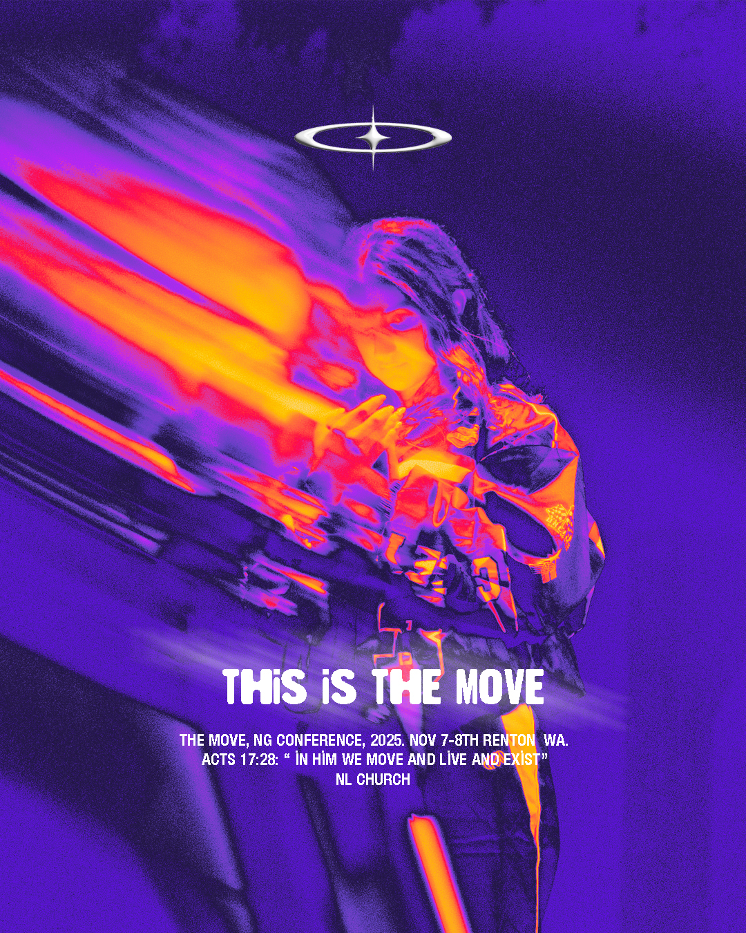
FAQ

What is Next Gen Conference?
At Next Gen Conference you'll have the opportunity to encounter God and be inspired and equipped to live out your faith in the world. With powerful worship, inspiring speakers, and meaningful connections with other young believers, Next Gen Conference is an experience you don't want to miss.

When is it?
This is a two-day conference on November 7th-8th.

Where will the conference be located?
It will be at New Life Church in Renton, WA.

What is the cost?
The cost will be $65 for the first 10 people who sign up and pay a $40 deposit. After the first ten people sign up the cost will go up to $85 for those who sign up pay a $40 deposit by Oct. 19th. All remaining money needs to be turned in by November 2nd. You can pay when you register online or drop off cash or check at youth service on a Sunday.

How will meals work?
You will need to provide money for 2 meals while we are at conference: Dinner on the way to conference and lunch on Saturday. Breakfast will be provided.

OPTIONAL: There will be an after party on Friday night where students will have the opportunity to buy food and snacks. If your student is interested in this, please provide some extra spending money.

Where will we be sleeping?
We will either be staying in a hotel or housed at a local church. We will confirm when we get closer to the event.

What time will you leave and return?
In order to get to the New Life Church campus for registration on time we ask that you arrive at the youth building at 3PM on November 7th. Our goal is to return to church around 6pm on November 8th.

If there is an emergency how can I contact the Youth Pastor?
My cell phone will be off during sessions, however, I will check my messages during the breaks. So, if there is an emergency you can call my cell phone and leave a message. I will contact you as soon as possible.
Cell Phone Number: Dani Klee 360-261-2407

Are students allowed to bring their cell phones?
Students will sign a cell phone contract agreement that will allow them to bring their cell phones. Students will be asked to keep the cell phone in airplane mode during the duration of the conference. Students will not be allowed to make outside contact with friends and family except in cases of emergency. Students will be allowed to take pictures to capture memories, but will not be allowed on any social media during the duration of the conference. We ask that all cell phones are shut off once sessions begin. Our goal is to foster an environment where students can unplug from their world of technology and plug into what God has for them.

____________________________________________________
Conference Schedule:
Friday 1st |
6:30PM | Doors Open
7PM | First Service
9PM-11PM| After Party

Saturday 2nd |
9:30AM | Doors Open
10AM | Second Service
11:30AM | Collab Breakout Sessions.
12:30PM | Lunch
2:30PM-4PM | Final Service

WHAT TO BRING TO NEXT GEN CONFERENCE

  Bible & Pen
  Notebook or Journal
  Deodorant, Toothbrush/Toothpaste & other necessary toiletries
  Clothing for 2 days
  $$ for espresso bar, snacks, merch
  $$ for 2 Meals - (Dinner Friday & Lunch and Dinner Saturday)

WHAT NOT TO BRING TO
NEXT GEN CONFERENCE:
- Weapons
- Electronic devices (portable game systems, etc.)
- Vapes, drugs, cigs or the like

